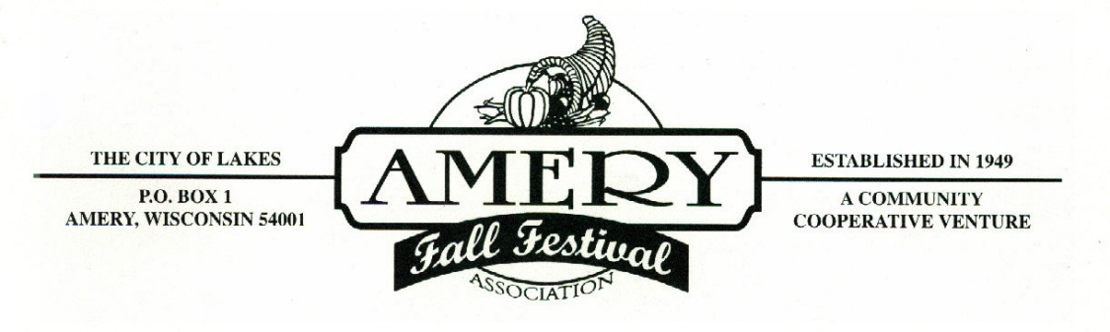

2016

Greetings,

Once again it is time to extend our invitation to you and/or your group to participate in the 2016 Amery Fall Festival Parade. The parade is always on the second Saturday after Labor Day, which makes this years Parade on Saturday September 17, 2016 at 10:30 a.m.

Enclosed you will find a copy of our “Parade Regulations,” and a parade entry application, which we ask you to complete and return at your earliest convenience. The parade entry deadline is August 24, 2016, and will be strictly enforced. Any entries POST MARKED after this date will not be guaranteed placement in the parade. Line-up is based on the date the entry form is received.

Please make any special requests for placement at the time of registration so we can try and facilitate your needs. These needs will be filled on a first come first serve basis. All parade participants will receive a letter with placement information and instructions approximately 10 days prior to the parade. Changes after this point cause too many difficulties to the rest of the line-up, and will be VERY limited. Also, with most parade floats having music, it is getting difficult to spread the floats out based on music/no music, so please beware you may be next to another float with music. Please keep the music volume to a minimum.

Please note on the “Parade Entry Application” that we are requesting your email address. We are requiring this in an attempt to primarily do more email correspondence next year, so please give us an email that will work for years to come or the new contact email for next year.

We look forward to seeing you this fall and thank you in advance for helping to make our event special each year.

Sincerely,

Deb Palmberg Kelly Lathrop

Deb Palmberg Kelly Lathrop
Amery Fall Festival 2016 Parade Co-Directors

Email- ameryfallfestivalparade@yahoo.com
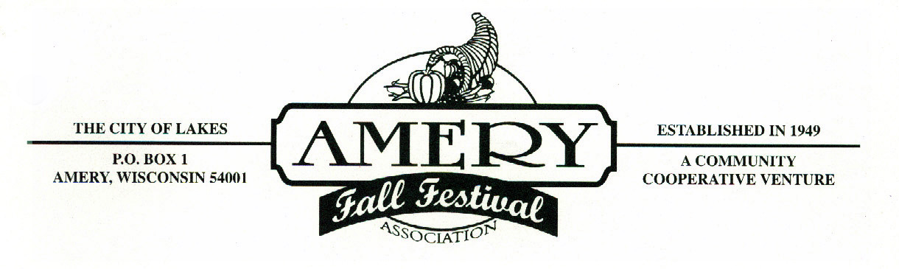
The parade entry deadline is August 24, 2016

Thank you for your interest in our Fall Festival Parade.

Please provide the following information regarding your float/unit. Upon completion, please return to the attention of Amery Fall Festival Parade via e-mail at ameryfallfestivalparade@yahoo.com or via mail to PO Box 1, Amery, WI 54001.

Unit description (circle one): Organization Royalty Band

Name of Unit:

Type of Unit (circle one): Float Large/Semi Truck #_______
Car/Pick-up Truck Horses #_______
Tractors #_______ Walkers #______

Will your float/unit have music (circle one)? Yes No

Use back of page if needed for the following:
Description of unit for Parade MC – estimated overall length/space required:

Name(s) & Title(s) of participants:

Contact Person:
Mailing Address:

Phone Number(s):

E-mail Address (helpful):

Special instructions/requests:
More on back
2016 Amery Fall Festival Parade Regulations

All parade units must incorporate some entertaining aspect in their parade unit. No purely commercial units will be accepted, unless they are one of the 12 winners for the Amery Community Club monthly businesses.

Political Individuals/Candidates/Groups will be required to pay a non-refundable $50 participation fee with their registration.

Absolutely no items can be thrown from any unit during the parade. Individuals must walk along side and distribute goodies close to the curb.

Late arrivals will be placed at the end of the parade.

If you intend to use an animal to pull a float/cart, etc., you will be placed towards the back of the parade.

Horses/cattle/etc. will be placed towards the end of the parade, for obvious reasons.

All units are asked to maintain a brisk pace, and to follow the directions of the parade officials along the parade route.

Any disabled vehicle must be removed from the parade route as soon as possible.

All units must enter the line-up area through North Park or assigned street.

The Amery Police Department has requested that all units close their floats on any side street, but not on Keller Ave.

Thank you for your compliance with the above rules. We are sure they will benefit all concerned.

Fall Festival Parade Committee

